VISHAL BHATT

Chief Information Security Officer | Cybersecurity Strategist | Compliance & Risk Leader
Anand, Gujarat | veby00 9@gmail.com | +91-9428219280
lin ked in .com / in/ vishal - b h att-b 030 671 8 | GitHub: github.com/veby009

Professional Summary

Information Security Leader with 24+ years of experience building, securing, and managing enterprise IT infrastructure across finance, telecom, and IT services. Proven success in aligning cybersecurity programs with RBI, SEBI, DPDP, and ISO 27001 requirements. Known for leading VAPT, application security, regulatory audits, cloud transformation, and awareness training. Skilled in securing multi-site operations, mitigating risk, and driving compliance as a board-level
representative.

Core Competencies

• Cybersecurity Strategy & Governance

• Information Security Policy Implementation

• RBI, SEBI, DPDP, ISO 27001 Compliance

• Application Security & VAPT

• Risk Assessment & Incident Response

• Data Loss Prevention (DLP) & Infrastructure Hardening

• Identity & Access Management (IAM)

• Security Awareness & Training Programs

• IT Budget & Vendor Management

• Cloud Infrastructure Security (AWS, Azure)

• Disaster Recovery & Business Continuity Planning

• Leadership & Cross-Functional Team Management
Key Projects

• ESXi 6.5 Server Deployment – Virtualization deployed in 7 days, enabling secure infra base

• Windows Server 2022 VM Rollout – Reduced costs by 15%, improved efficiency by 20%

• Helpdesk Server Implementation – 30% increase in first-call resolution rate

• CRM Server Migration – Sales productivity +20%, customer satisfaction +15%

• CKYC-UAT & Production Server – Improved performance by 20%, 25% less downtime

• Cloud Telephone SmartFlow – Delivered 20% efficiency gain

• WhatsApp Bot Project – Engagement improved by 30%, response time down 20%

• Biometric + Iris Security Rollouts – Achieved 30% higher adoption, reduced attendance fraud

Professional Experience

Senior IT Manager

Arman Financial Services Ltd. | 2023 – Present | Ahmedabad

• Defined and executed enterprise-wide cybersecurity policies aligned to ISO 27001 and
RBI

• Led internal audits, penetration tests, and security controls for regulated infrastructure

• Represented IT risk at board-level audit and compliance reviews

• Oversaw DLP, IAM, and cloud governance functions

• Trained 150+ staff on cyber hygiene and phishing prevention

IT Manager

Entigrity Pvt. Ltd. | 2021 – 2024 | Ahmedabad

• Led secure hybrid cloud migration and zero-trust strategy implementation

• Managed helpdesk systems and remote access security for international teams

• Reduced vulnerability by 40% through rigorous VAPT processes and DevSecOps adoption

IT Manager

KomalTex Fab Pvt. Ltd. | 2017 – 2021

• Oversaw IT policy creation, vendor security, and core data security layers

• Strengthened backup/recovery protocols, reducing RTO by 35%

Technical Head / Coordinator

IIHT Ltd. & Jetking Infotrain Ltd. | 2007 – 2017

• Managed multi-center infra, IT training, and system security audits

• Led ISO-compliant QMS and network standardization rollouts

Education

• B.Sc. Physics (Electronics)
R.G. Science College – Gujarat University | 2000

Certifications



I ntrodu cti on to Ar ti fici al I ntel l i gen ce I ntrod u cti on to Ar ti fici al I ntell i gen ce

Simp lilea rn Simp lilea rn Issu ed Jan 2025 Issu ed Jan 202 5 Cred enti al ID 7745 208 Cred enti al ID
77 4520 8

o Show cred enti al

I ntrodu cti on to Cyb ercrime I ntrod u ction to Cyb ercr i me

Simp lilea rn Simp lilea rn Issu ed D ec 20 24 Issu ed D ec 20 24 Cred enti al ID 772 3510 Credenti al ID
77 2351 0
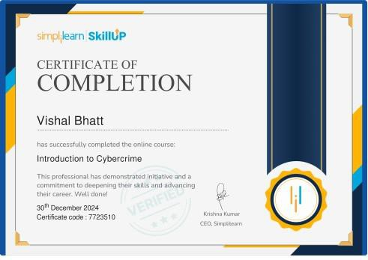o Show cred enti al

 77 2351 0_46 534 671 735 541 4166 49. p df 7723 510 _46 5346 7173 554 141 664 9. p d f

Certi fied I nfor mati on Systems Secu r i ty Professi on al (CISSP) Certi fied I nformati on Systems
Secu r i ty Professi on al (CISSP)

Simp lilea rn Simp lilea rn Issu ed N ov 202 4 Issu ed N ov 2 024 Credenti al ID 760338 5 Cred enti al ID
76 0338 5

o Show cred enti al

Skills: Cybersecurity and Risk Management Skills: Cybersecurity and Risk Management
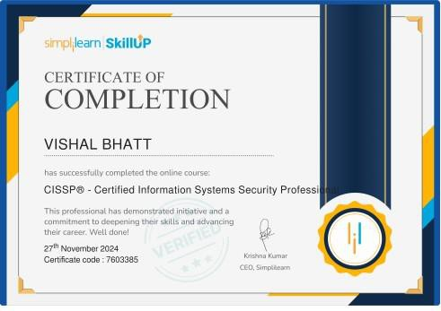

 76 0338 5_46 534 671 732 704 9582 46. p df 7603 385 _46 5346 7173 270 495 824 6. p d f

Eth i cal Hacki n g for Begi nn ers Eth i cal Hacki n g for Begi n n ers

Simp lilea rn Simp lilea rn Issu ed Oct 20 24 Issu ed Oct 20 24 Cred enti al ID 443 8439 Credenti al ID
44 3843 9

o Show cred enti al
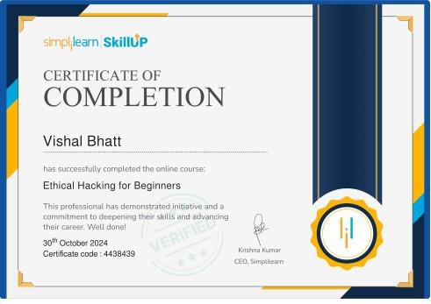

44 3843 9_46 534 671 730 271 6359 37. p df 4438 439 _46 5346 7173 027 163 593 7. p d f

Com p licati on o f Eth ical Hackin g for Begin ners Com p licati on o f Eth ical Hackin g for Beginn ers



A rch i tecti n g w ith G oo gle Ku b ern etes En gi n e I Begi n n er Ch amp ion Certificati on . A rch i tecti n g
w i th G oogle Ku b er netes En gi n e I Begi n n er Ch amp i on Certi ficati on.

Tech GigTech GigIssu ed Ju l 20 24 Issu ed Ju l 2024 Cred enti al ID 2024 0709 193 498 Credenti al ID
20 2407 0919 349 8

o Show cred enti al

Skills: Compliance RegulationsSkills: Compliance Regulations



Co re I nf rastr uct u re I Begi n n er ski ll G CP Co re I nf rastr u ctu re I Begi n n er skil l G CP

Tech GigTech GigIssu ed Jun 2024 Issu ed Ju n 2024 Cred enti al ID 2024 062 872 132 8 Cred enti al ID
20 2406 2872 132 8

o Show cred enti al
Skills: Compliance RegulationsSkills: Compliance Regulations



A rch i tecti n g w ith G oo gle Ku b ern etes En gi n e I Begi n n er Ch amp ion Certificati on . A rch i tecti n g
w i th G oogle Ku b er netes En gi n e I Begi n n er Ch amp i on Certi ficati on.

Tech GigTech GigIssu ed Jun 2024 Issu ed Ju n 2024 Cred enti al ID 2024 070 919 349 8 Cred enti al ID
20 2407 0919 349 8

o Show cred enti al

Skills: Compliance Regulations

Technical Skills

• Security: VAPT, DLP, IAM, SOC, Firewall, Endpoint Protection

• Compliance: ISO 27001, RBI, SEBI, DPDP, IT Act

• Infra: ESXi, Active Directory, Azure AD, VPN

• Cloud: AWS, Azure, GCP

• Monitoring: SIEM, SolarWinds, ManageEngine

• Tools: Jira, GitHub, Bitbucket, Zabbix, Nessus

Languages

• English: Professional

• Hindi: Fluent

• Gujarati: Native

